Chapter 11, Solution 59.

Calculate the reactive power in the inductor and capacitor in the circuit of
Fig. 11.78.

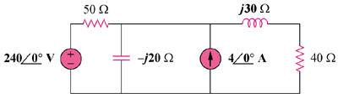

Figure 11.78
For Prob. 11.59.

Solution

Let V_{o} represent the voltage across the current source and then apply nodal analysis to the circuit and we get:

Reactive power in the inductor is
j339.3 VAR

Reactive power in the capacitor is
–j1.4146 kVAR

